The Medicine Delivery Robot

Senior Design Proposal submitted to the

Department of Mechanical and Materials Engineering

College of Engineering and Applied Science

University of Cincinnati

in partial fulfillment of the

requirements for the degree of

Bachelor of Science

in Mechanical Engineering Technology &

Computer Science

by

Kevin Blount, Anthony Dietz, and Brock Stechschulte

April 18, 2020

Thesis Advisor:

Dr. Janet Dong

**Table of Contents**

**Problem Statement** **4**

**Research** **4**

Background of the Problem 4

Current State of the Art 5

Current State of the Art for Design 6

Summary of Research 8

Product Objectives 9

End User 9

**Quality Function Deployment** **10**

Example Survey 10

Customer Features 10

Engineering Characteristics 10

House of Quality 11

Relative Weighting 11

Key Characteristics 12

**Concept Drawings** **12**

Concept 1 12

Concept 2 13

Concept 3 14

**Final Design** **15**

Overall Design 15

Medicine Storage Compartment 16

Indexing Mechanism 16

Ultrasonic Sensor 17

Alarm 18

Battery 18

Drink Holder 19

Drink Holder Stress Analysis 19

Alarm and Ultra-sonic sensors Design 20

Bottom Lid Design & Stress Analysis 21

Lid Stress Analysis 21

Force, Power and Torque Calculations 22

Drive Train Design 23

Gear Ratio and Gear Selection 23

**Project Management** **24**

Project Budget 24

Parts to 3D Print 24

Parts to Buy 25

**Future Steps** **25**

**Development** **26**

Alarm 26

Ultrasonic Sensors 27

Index Motor 29

User Interface 30

GitHub Code Repository 30

**Project Management** **31**

Meeting Log 31

**References:** **33**

# Problem Statement

For our project we are tackling the problem of how hard it is for senior citizens receive their medications in their own home. To resolve this problem, we are creating The Medicine Delivery Robot. This robot will deliver a person’s medicine to them wherever they are in their home. As a team we have all witnessed senior citizens have a tough time remembering to take their medicine, or not to be physically able to retrieve their medicine. As engineers it would be fulfilling to build and program a robot that would navigate your home and deliver important medications to the person in need.

# Research

### Background of the Problem

Every single day there are senior citizens that struggle to take their prescribed medicine from doctors. “Approximately Fifty-five percent of the elderly are non-compliant with their prescription drug orders, meaning they don’t take their medication according to the doctor’s instructions.” (6) There are four main reasons senior citizens do not take their medicine correctly and they are vision problems, memory loss, hearing problems, and social isolation. Senior citizens with vision problems could have a hard time moving around their house and seeing the correct medication to take at the correct time of the day. People with this problem could injure themselves trying to maneuver their house or take the wrong medications. Elders that have dementia, Alzheimer’s, or memory loss have a very hard time remembering when to take their medicine or if they have already taken their medicine. This is very dangerous because it could lead to severe health problems or an overdose that could be deadly. When a senior has a hard time hearing it can be difficult to understand what the doctor is saying when going through the instructions to take the medicine. This problem could lead to taking the medicine at the wrong time or the wrong dose of medicine. The final reason that senior citizens sometimes forget to take their medicine is social isolation. Most elderly people live by themselves and according “Several studies have shown that people who live alone more frequently fail to comply with their medicine regimens.” (7)

Currently the most common ways seniors are assisted in taking their medicine are by a hired caregiver, family members helping them out, or being put into a senior assistance living center. A hired caregiver is required to go to the elderly’s house every day at the designated times for the patient to take their medicine. This can be really taxing on the caregiver if the person is required to take medicine multiple times a day. When the family doesn’t have money to hire a caregiver they are required to take time out of their day from their job to travel to the seniors house to make sure they take their medicine correctly. The final way to make sure the senior citizen will receive their medicine correctly and at the correct time is to be enlisted into a senior assisted community. From experience, family members that are put into care like this feel like their family will forget about them. All these problems can be solved with creating a medicine delivery robot that will help senior citizens receive their medicine correctly.

### 

### Current State of the Art

Some of the current robotic delivery systems that are currently on the market are being developed in the United States, and other countries such as Japan. One of these products that is paving the way for others is called Tug. Seen in *figure 2*, Tug was developed by Aethon and is a fully autonomous robot that helps hospital staff in many ways. It can autonomously deliver food and medicine to different parts of the hospital. If a nurse requests a certain medicine for their patient, the pharmacy department can load it into Tug, and it will transport it to the nurses. Tug works by using lidar sensors to sense the world around it (2). It bounces lasers off the objects and creates a highly detailed, 3D map in order to position itself and successfully navigate the hallways. Tug is one of the beefier robots that we looked at. It comes in different versions such as the Tug T3, Tug T3XL or The Drawer. All of these have a 10-hour operation time and at least a 1,000 lbs payload capacity (3). A cool feature that Aethon added to Tug is that they can monitor all of their units around the country from their own facilities to help bring peace of mind to their customers and the people who physically interact with the system on a daily basis (2).

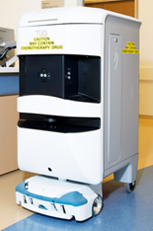

**Figure 3: Tug**

Another robotic delivery robot is called Hospi. Seen in figure 4, Hospi delivers food and medicine in the same way as Tug does. Being developed in Japan, it is currently going through different trials to make sure it is safe for a hospital environment. Hospi comes programmed with a map of the hospital that it is working in. It uses that information along with ultrasonic sensors to get its contents from one part of the hospital to another in a timely manner (4). Another key feature of Hospi is its state-of-the-art security. The only people who can access the contents inside during a delivery are those with proper ID cards and the correct code for that specific delivery. This is to ensure that no one tampers with the sensitive medication or blood results that could ultimately completely change the state of the patient. The Hospi unit weighs approximately 345 lbs (170 kg), delivers a maximum payload of 45 lbs (20 kg) and can operate for 9 hours on battery power (5).

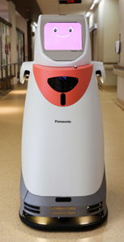

**Figure 4: Hospi**

The innovation of these robots is quite amazing when you take a second and look at what they can do seems like something out of a science fiction novel. The main benefits of using these robots are that it frees up medical staff to focus on more important tasks and helps to eliminate human error. Fixing these issues will make the hospitals more efficient and prevent the misplacement of important and expensive medicine.

With all these great benefits that these robots bring to their commercial environments, they would not be well suited for a privatized environment. When you look at a hospital, you see a consistently solid floor all throughout the hospital building. When we implement our robot into a home setting, people can have either hard floors, carpets, and a lot of times a mixture of both. Our robot will need to have a drive train that is designed to traverse these different types of flooring and not get hung up on transitions between them.

Another flaw that we can see with these robots, if you can even call this a flaw, is that they are over engineered for a home environment. When they are making their way through a hospital, they have many different factors that the engineers need to account for. A constant stream of people moving in all directions, different types of carts moving through the hallways, and many different floors they need to get to. For a home, we won’t have to worry about going up an elevator, and we won’t see the same amount of traffic going through the hallways on a daily basis. This is going to allow us to focus our efforts elsewhere to improve our product for its intended use.

### Current State of the Art for Design

For this project I have been delegated to design and create the structure of the robot. Currently there are a lot of different designs of delivering robots on the market. These robots are very expensive and much more complex than the robot that we are designing. The number one delivery robot on the market right now is called Relay. This robot was developed by Savioke and is a completely autonomous robot that securely stores items such as food, medicine and other small items. This robots design is very complex and has touch screen compatibility and has a very high security system to make sure that your items do not get lost or stolen along the way. This robot is very expensive and not meant for household use. This robot can be found in hospitals and a wide variety of public spaces. (6)

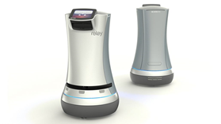

Figure 1: Relay Robot

There are currently a wide variety of delivery robots on the market but none seem to be domestic. Currently amazon is testing the amazon scout, this autonomous robot will deliver packages to houses around a community and then move on. Also FedEx has created something similar called the SameDay Bot, this autonomous robot is designed to deliver products to the customer the same day. The design of the amazon scout is different than the SameDay robot because it has six small wheels and is has a smaller compartment. The FedEx robot has a large carrier compartment elevated above four large wheels with two smaller wheels on the front for balance. The FedEx robot has the ability to climb stair to be able to deliver your product directly to your front door. These robots are more of a rover design with six large wheels to be able to maneuver any terrain that it might encounter on the streets when delivering packages to the customer.

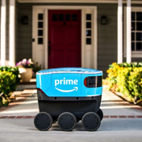

Figure 2: Amazon Scout Robot

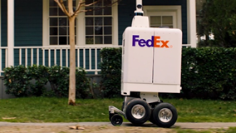

Figure 3 FedEx SameDay Robot

There are some household robots that can maneuver throughout a house to do certain tasks and the one that is most known is the Roomba from iRobot. This robot maneuvers your house and vacuums and sweeps the floor for you. This robot is very small and a cylindrical design so it does not get stuck on corners and can bounce off walls without damaging them. Some down sides with the Roomba robot is that it is limited to only sweeping the floors of the household. Also this robot is very expensive for its limited capabilities. The company iRobot manufactures five different models of the Roomba, the cheapest model sells for $274.99 and the most expensive model sells for 1,399.99. (8)

### Summary of Research

Just like Tug and Hospi, our medicine delivery robot has the potential to change people’s lives for the better. For someone who can’t retrieve their own medicine or forgets to take it, having a robot that serves as a reminder and can deliver them to your feet will bring great comfort to their loved ones and those who are caring for them.

Approximately 55 percent of senior citizens are non-compliant with taking their prescribed drugs correctly, this could lead to severe illnesses and a possible death or injury. There is definitely a need for a quick and cheap solution to this major problem. Our robot will be able to be programmed for any person’s needs. This medicine delivery robot will deliver a weeks’ worth of medication to the user at any moment during the day. This robot will help our senior citizens in our society live as long as possible and so the only thing that the families of these people need to worry about is when to see them, not whether they are taking their medication properly.

### 

### 

### Product Objectives

For our Senior Design project, we are building a medicine delivery robot that can be operated in someone’s home. There are millions of Americans and people around the world, who need medicine daily but getting up to retrieve it could be difficult for them. This could be due to mobility issues, or forgetfulness. With our robot, we are hoping to fill in this gap of home care for these patients all around the world.

The robot is a small and mobile vehicle that can autonomously navigate the hallways and rooms around your house. It will be equipped with sensors on the front, and both left and right sides, to navigate around various obstacles. Everything from a box left on the middle of the floor to those pesky clothes that you left lying around. For this project, I am ultimately in charge of the sensor technologies, battery selection, and all the wiring in order to bring together the overall design, and the programming software.

### End User

One of the end users intended for this robot would be caregivers. Those who oversee maintaining another person’s health to the best that they can. This could be a nurse that comes to check on a sick individual, or a parent that is caring for their child. The act of caring for someone can be a daunting task with having to continuously check up on them and just overall worry about their health and safety. This robot would help to shoulder some of that burden in a safe and effective manner.

### 

# Quality Function Deployment

### Example Survey

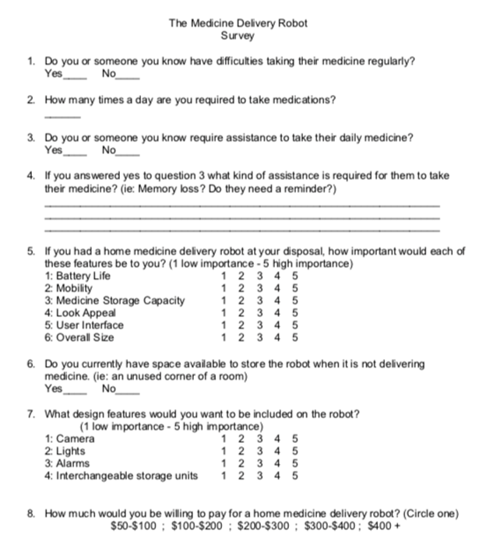

### Customer Features

The customer features that we included in our survey were Camera, Lights, Alarms, and Interchangeable Storage Units. When we analyzed the results and found the averages of the data, the rankings of most important to least were:

Alarms (4.33)

Lights (4.00)

Interchangeable Storage Units (3.48)

Camera (3.41)

### Engineering Characteristics

The engineering characteristics that we included in our survey were Battery Life, Mobility, Storage, Appeal, User Interface, and Overall Size. When we analyzed the results and found the averages of the data, the rankings of most important to least were:

User Interface (4.7)

Mobility (4.1)

Battery Life & Storage (3.9)

Overall Size (3.7)

Appeal (3.6)

User Interface deals with the overall programming of the robot and how the customer interacts with it, so this makes sense as to why it is the most important. To accomplish this, we will spend most of our efforts in making sure that it works flawlessly, and the different setup menus are easy to navigate even if they are technologically impaired.

### House of Quality

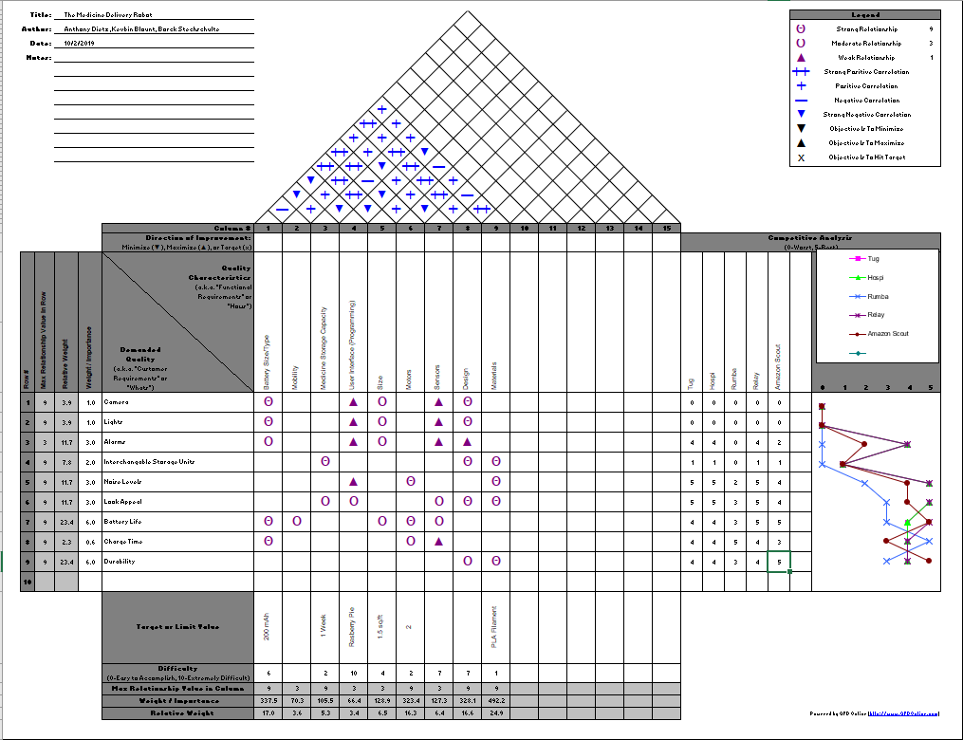

### Relative Weighting

The relative weight is located at the bottom of the House of Quality and lists a percentage of how important each quality characteristic is to complete our project and design. The characteristic that holds the most weight in our design is the materials at 24.9%. The characteristic that holds the least amount of weight is the size at 3.4%. Below is a full list of weighted percentages.

Battery Size/Type – 17.0%

Mobility – 3.6%

Medicine Storage Capacity – 5.3%

User Interface – 3.4%

Size – 6.5%

Motors – 16.3%

Sensors – 6.4%

Design – 16.6%

Materials – 24.9%

### Key Characteristics

One of the biggest results from doing our HoQ is that we noticed that the competing robots that are already on the market, they lack having a Point of View camera and lights. This is mainly because they are designed to work in well-lit environments, but it is an area that we can improve our product.

For engineering characteristics, the most important ones based on positive correlations are Design, Materials, Mobility, and Battery life. These 4 have the most positive or Strong Positive correlations relating to the others so we will need to focus on these areas in order to build a successful product.

# Concept Drawings

### Concept 1

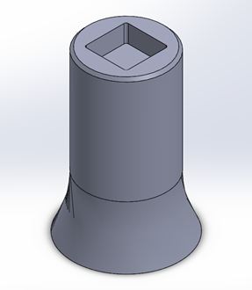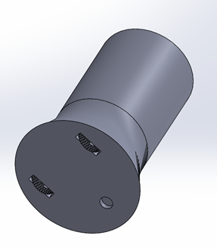

This robot concept is more of a tower design that will be able to move around your house. This design is much taller than any of our other designs it stands about 3 feet tall and is a foot and 1.5 feet in diameter. It will be able to move around on two wheels throughout the house. We created this concept because this robot will be easier for the customer to reach their medicine instead of bending down to pick up their medicine.

### Concept 2

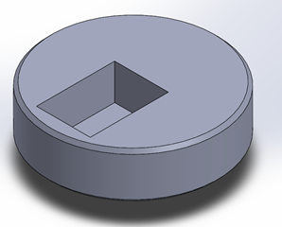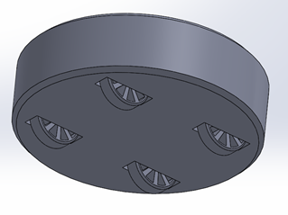

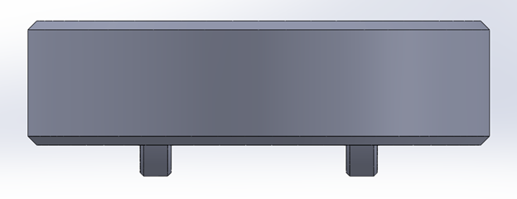

This robot design is much smaller than the tower design and will be able to move around more easily than the tower design. This design only stands about 8 inches off the ground and is 1.5 feet in diameter. This robot design will maneuver on four wheels throughout the house and will be able to make quick and precise turns. This design will be able to be stored much easier in your house than the tower design just due to the size of the robot. The medicine will be stored on the top of the robot for easy access for the user.

### Concept 3

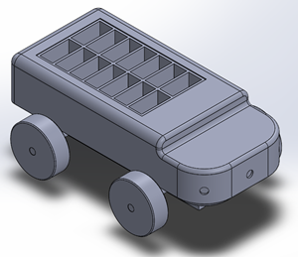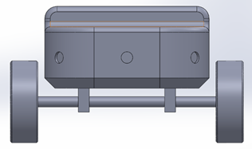

For this concept design we decided to create more of a rover design. This robot is designed to be able to navigate and maneuver more of a cluttered household. Because this robot has four wheels not directly under the robot, it will not get stuck or have trouble going over clothes or other small objects in the way as it moves around the house. This robot is about 1.5 feet wide, 2 feet long and sits about 10 inches off the ground. With these dimensions it should be able to be stored in a person’s home very easily.

# Final Design

### Overall Design

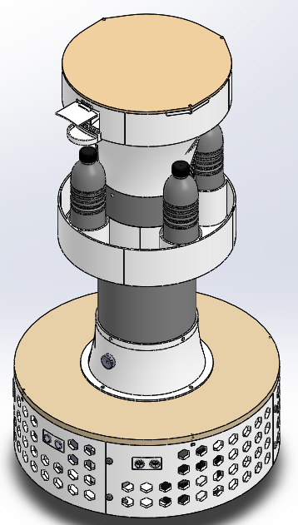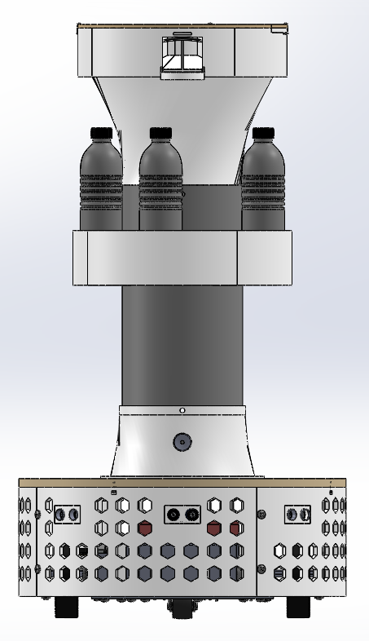

The final design of our medicine delivery robot is a variation of the tower design that we proposed in our initial report from Senior Design 1. When we were debating on the different designs to go with, we had to think of how this product would be used by the end user. The other two designs that sat low to the ground would have greatly reduced the material needed, therefore bringing down the cost. However, if an end user already has a disability and a tough time moving, the last thing they will want to do is bend down to the floor to pick up their medicine. This led us to believe that the tower design was the most viable option to start with.

When we first presented the idea of the tower design medicine dispenser, one of the questions that was asked of us was how the end user will get water for their medicine. Most often, people need a sip of a drink in order to get their pills to go down smoothly, but the basic concept we had designed before left no room for water. To incorporate water easily into our design, we slimmed up the tower portion and added a drink holder in the middle. Not only did this allow us to add easily accessible water bottles, but also cut down on cost of material and overall weight of the robot.

This final design stands at 32.5” tall and is 18” in diameter at the base. These dimensions are crucial so that it can easily navigate throughout a home and sit at an average height of males and females.

### Medicine Storage Compartment

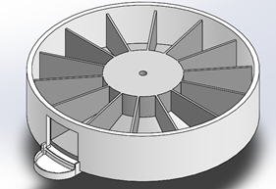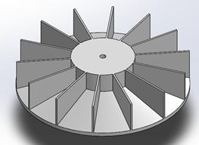

For our storage compartment, we went with a circular design that has 14 individual slots. This will allow the end user to have enough compartments to last them 2 weeks’ worth of medicine at one dose per day, or a full week of medicine at two doses per day.

The slots will be rotated around at the desired time intervals so that each time medicine is requested, the new days’ worth will be in front of the compartment door and ready to be received. On the rotating compartment itself, the bottoms are slanted so that when the end user opens up the door, the medicine will fall out into the catch tray.

### Indexing Mechanism

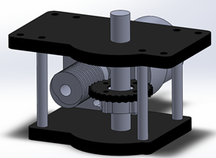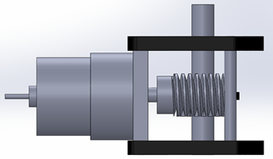

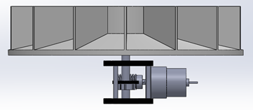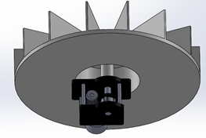

In order to turn our medicine tray, we needed an indexing mechanism with enough precision to line up the compartment slots accurately and repeatedly. The device also needed to be light and compact enough to fit into our upper tower portion of the robot, and not add too much weight so the body could not support it. For this task, we decided to go with a worm gear mechanism that will transfer our power to a 90-degree angle. The gears themselves are a 30:1 ratio so that we can get a slow and smooth rotation, allowing it to be more accurate and repeatable. The nature of a worm gear greatly minimizes backlash within the system, so we won’t need to worry about the mechanism shifting out of place. The drive motor is a 12V DC gear motor with an encoder on the back. Under no load, it spins at 200 and draws a max current of 1.5A. With this setup, the motor will spin the compartment at 6.67 rpm, a manageable speed to allow us to accurately shift the compartment each time the next set of medicine is ready to be dispensed.

### Ultrasonic Sensor

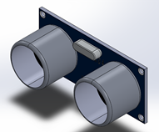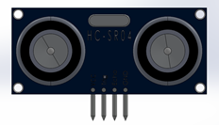

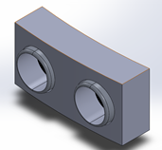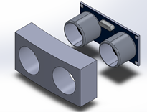

The ultrasonic sensor we are using is a 20mA Parallax PING Ultrasonic Sensor. This will be used to sense the path in front of the robot so that it can detect if there are any objects in its way. There will be three sensors total. One in the center facing forward, and two places on the left and right side at a 45-degree angle. This will give us an optimal view of the front space to detect anything objects. The sensors themselves have a sensing range of 2cm to 3m. 3m is obviously too far, so we can adjust that distance, so we aren’t causing unwanted problems with our robots’ movement.

### Alarm

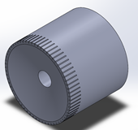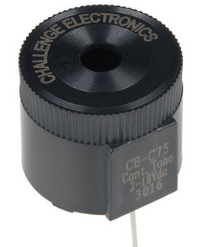

Our chosen alarm is a Large Piezo Alarm. At 3KHz, it has a decibel output of 100 which is roughly equivalent to the sound of an average motorcycle. This will serve to alert the user for any number of reasons such as the robot having arrived with your medicine, or that it is stuck at an object and needs some assistance.

### Battery

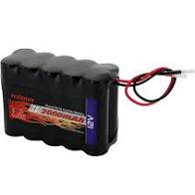



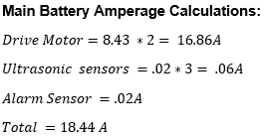

In order to deal with the different voltage levels of the devices, we have three separate batteries. The Raspberry Pi is powered by a 3.7V battery, the indexing motor is powered by a 12V battery, and the drive motors are powered by 2 12V batteries wired in series.They are wired in series in order to increase the voltage to 24V and power the 24V drive motors. The motors draw 9 Amps of current so these batteries will allow the robot to function nonstop for a whole hour. Realistically, the robot will only be operational for 10-15 mins of the day so this will give you 4-6 days of run time before a charge is needed.

### Drink Holder

The drink holder is a very key design concept that we came up with when we were designing our robot. People are going to need something to drink when they take their medicine. This drink holder is designed to hold 4 regular 12oz bottles of water. Each water bottle weighs about .92lbs totaling about 3.6 lbs of force. When running a stress analysis of the 4 forces, the max deflection of this compartment is .000258in. This is a very stable design for this key concept.

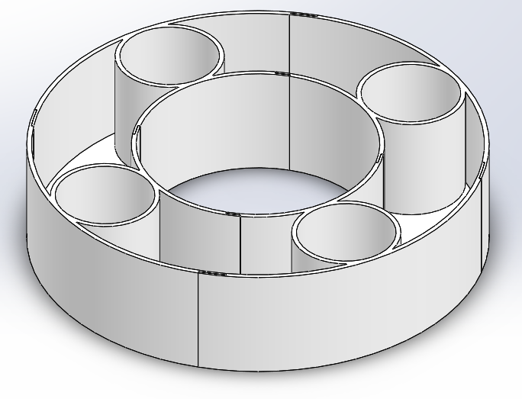

#### Drink Holder Stress Analysis

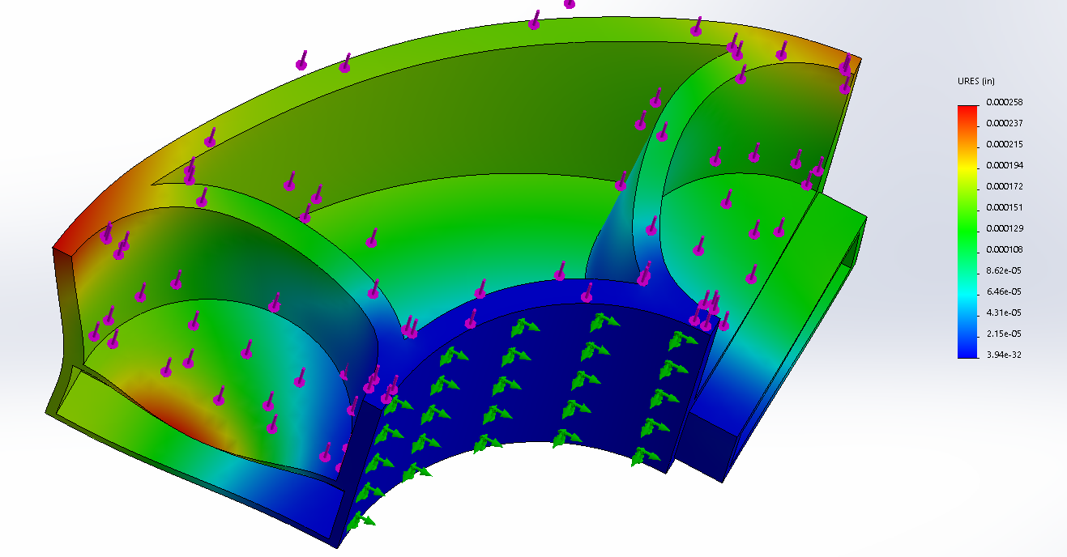

### 

### Alarm and Ultra-sonic sensors Design

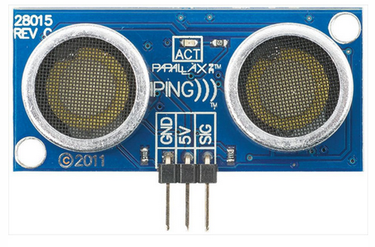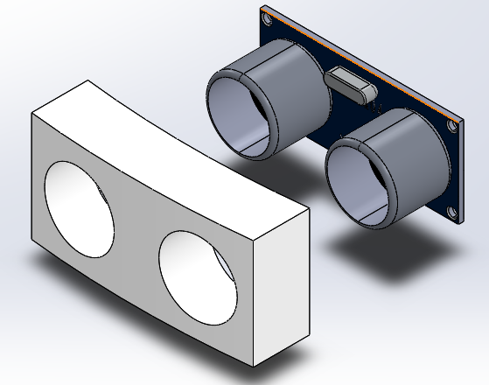

The three ultra-sonic sensors shown above are placed at 45° intervals from the centerline of the robot. These ultra-sonic sensors will be crucial for avoiding objects and maneuvering the robot around the house. A single ultra-sonic sensor provides precise, non-contact distance measurements within a 2 cm to 3 m range. (10) The alarm that is placed on the tower above the base is designed with a basic 100 decibel alarm that will alert the customer when the robot is near them or when the robot needs to be refilled.

### Bottom Lid Design & Stress Analysis

When creating the bottom lid Design we had to use a standard width that Baltic Birch plywood is manufactured in. So the width we chose for the lid was 18mm or .472in. The lid has a hole in the middle of iot to allow the wires from the indexing mechanism to be able to travel to the Raspberry pi.The entire top half of the Mobile Delivery Robot weighs 10lbs. Also, taking into account that a regular water bottle weighs about .92lbs and with 4 cup holders for water bottles the total amount of weight that the bottom lid will endure will be 13.68lbs.

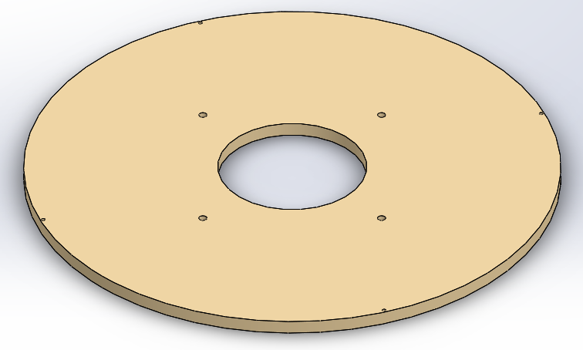

#### Lid Stress Analysis

With a load of 13.68lbs the bottom lid will have a deflection of .0004in. This is plenty safe to handle the load of all the compartments that are above the bottom lid.

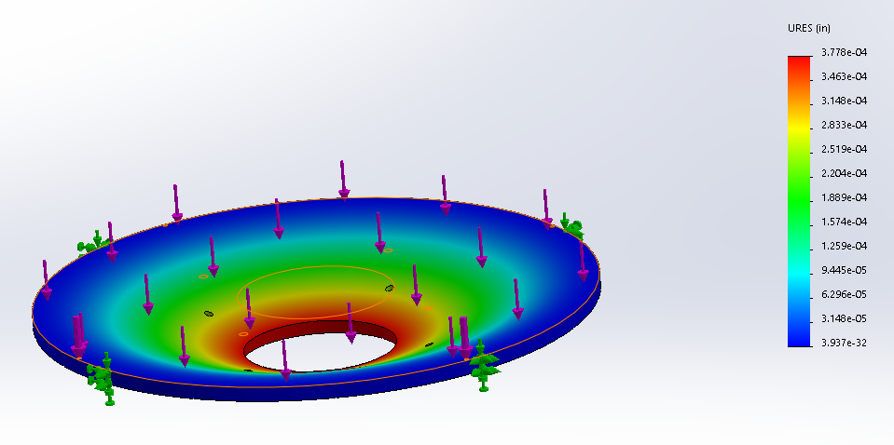

### 

### Force, Power and Torque Calculations

When Calculating the amount of force required to make our robot move we assumed the worst conditions possible. We assumed that the robot was moving up a 4.8°incline on concrete which has the highest coefficient of friction of all the possible surfaces that the robot can encounter. We calculated our robot to be 40lbs and added a safety factor of 1.5 to increase the total weight to be 60lbs to do our calculations. When going through the force calculations we found that it will take 52.85 ft*lbs. of force to move our robot up the incline. Taking that applied force and multiplying it by the desired velocity of 4.54 ft/s (the average walking velocity) we will get the power output of 239.94 lbs*ft/s. 1hp = 550 lbs*ft/s so our robot will need 0.436 hp from the motors to move the robot. Again, using the force applied of 52.85 ft*lbs. we can find the torque of the robot my multiplying by the radius of the wheel that we are designing. The wheel is 4 inches in diameter so the radius will be 2 inches. Creating a torque of 8.8 lbs*ft of torque per wheel. The total torque will be 17.62lbs*ft from both wheels.

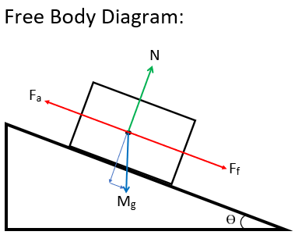

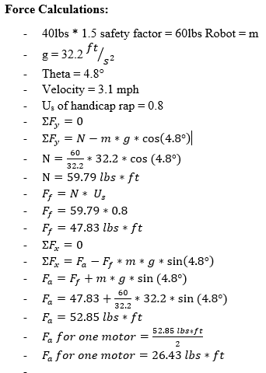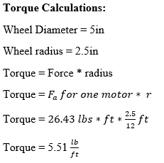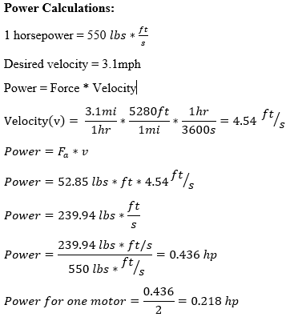

## 

### Drive Train Design

The way the robot is going to move around the house is with two drive wheels and a swivel wheel on the back. Each wheel is going to be powered by a DC motor that will give enough horsepower for the robot to move around effectively. Also, these DC motors will be geared down with a gear train to provide greater torque and less RPMs for the robot to move efficiently. The swivel on the back will allow for balance and easy turning in tight areas in a house. The swivel sits on a spacer that is the perfect distance off the bottom of the robot so that it sits on the same plane as the wheels. Located in between the wheels and the swivel will be the battery that will power the entire robot. This battery will power both motors, the raspberry pi with the 3 ultra-sonic sensors and alarm, and will power the indexing motor located in the medicine compartment. The Raspberry Pi is also mounted next to the battery in the Drive train for easy access and does not take up much space.

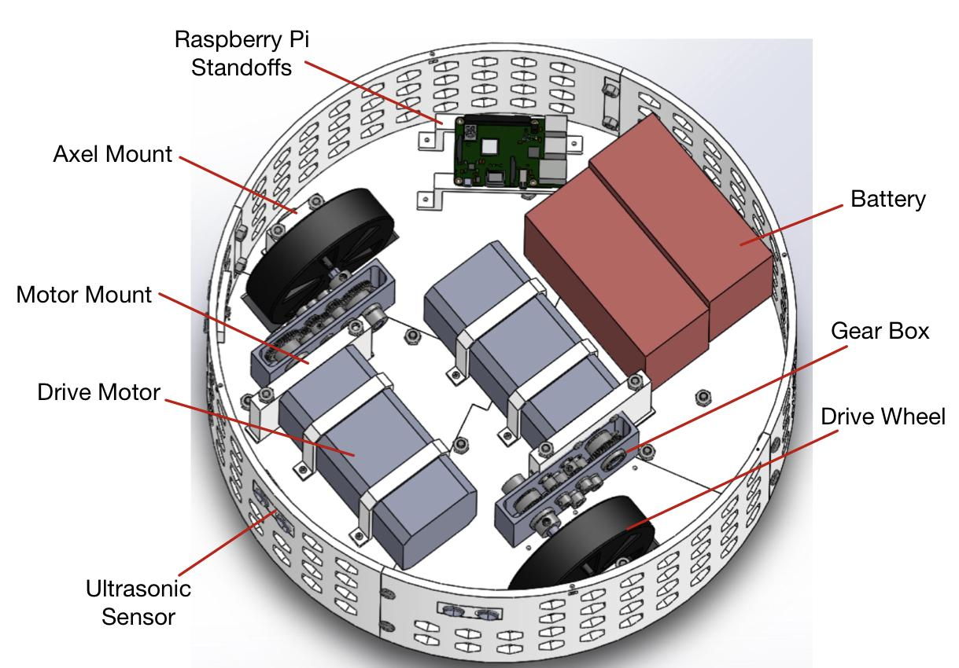

### Gear Ratio and Gear Selection

To find the correct gear ratio for the motor we first needed to look at the specs of the motor. Each motor generates .2 horsepower. These two motors added together will create enough power for the robot to move up a 4.8° incline. The output rpm for the motor that we chose to run at peak performance was 2900 RPMs. The calculated RPMs needed for the robot to reach a speed of 3.1 mph is about 208 RPMs. The Gear ratio needed for this reduction in RPMs would be a 11:1 gear ratio. The ratio we chose to go with is a 10:1 reduction so the motor can travel faster than the desired speed but not run the motors at full power the entire time. The orientation our gear train will be set up will be a reduction followed by two 12:36 reductions to the wheel axle. This setup will get us the desired gear ratio of 10:1.

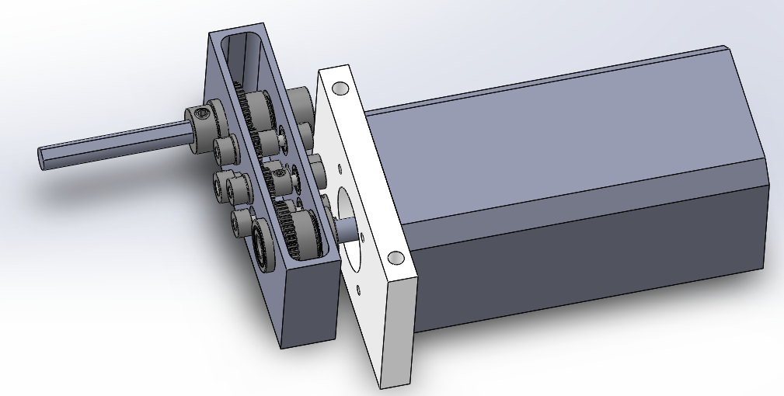

# Project Management

### Project Budget

This is a complete list of the parts that we plan to print for our robot build. The plan is to print these parts at the University of Cincinnati’s 1819 Innovation Center where the prints cost $0.13 per gram of filament. After completing our budget list and adding up the part totals, this has shown to be an extremely costly method of printing and we will look for new routes to take for our final prints.

Here is a complete list of parts that we have sourced from different providers to complete our robot build. It totals $577.41 and we believe this to be a very reasonable amount to spend.

#### Parts to 3D Print

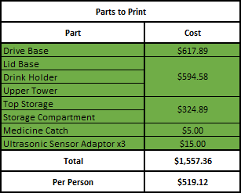

This is a complete list of the parts that we plan to print for our robot build. The plan is to print these parts at the University of Cincinnati’s 1819 Innovation Center where the prints cost $0.13 per gram of filament. After completing our budget list and adding up the part totals, this has shown to be an extremely costly method of printing and we will look for new routes to take for our final prints.

#### Parts to Buy

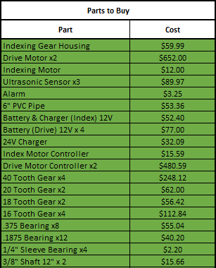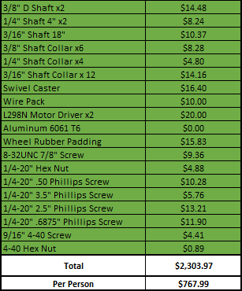

Here is a complete list of parts that we have sourced from different providers to complete our robot build. It totals $2,303.97 which is a high price but the cost for many of the parts would drop if ordered in bulk.

# Future Steps

Due to the outbreak of COVID-19, the production of important parts was halted overnight. The closing of the 1819 Innovation center and Victory Parkway 3D printing lab meant that we could not complete the tower sections and lids to our robot

### 

# 

# 

# 

# Development

### Alarm

package edu.uc.seniordesign.robot.skills;

import com.pi4j.io.gpio.*;

public class Alarm

{

private GpioPinDigitalOutput gpioAlarmPin;

public Alarm(GpioController gpioController)

{

gpioAlarmPin = gpioController.provisionDigitalOutputPin(RaspiPin.GPIO_26, PinState.LOW);

gpioAlarmPin.setShutdownOptions(true, PinState.LOW);

}

public void soundAlarm()

{

System.out.print("Alarm is off \n");

gpioAlarmPin.pulse(300, true);

System.out.print("Alarm is on for .3 seconds \n");

System.out.print("Alarm is off \n");

}

public void soundAlarmBackwards()

{

gpioAlarmPin.high();

System.out.print("Alarm is on \n");

try

{

Thread.sleep(300);

}

catch(InterruptedException e)

{

System.out.print("Alarm Error! \n");

}

gpioAlarmPin.low();

System.out.print("Alarm is off \n");

}

}

### Ultrasonic Sensors

package edu.uc.seniordesign.robot.skills;

import com.pi4j.io.gpio.*;

public class UltrasonicSensor

{

private final static int CONVERT_NANO_TIME_TO_CM = 58310;

private final int TIME_UNTIL_TRIG_TIMEOUT = 1000;

private final int TIME_UNTIL_ECHO_TIMEOUT = 17493000; // Max Distance of 3 meters

private long startTime, endTime;

public GpioPinDigitalOutput trigPinOutput;

public GpioPinDigitalInput echoPinInput;

public UltrasonicSensor(GpioController gpioController, int TrigPin, int EchoPin)

{

trigPinOutput = gpioController.provisionDigitalOutputPin(RaspiPin.getPinByAddress(TrigPin), PinState.HIGH);

echoPinInput = gpioController.provisionDigitalInputPin(RaspiPin.getPinByAddress(EchoPin), PinPullResistance.PULL_DOWN);

trigPinOutput.setShutdownOptions(true, PinState.LOW);

echoPinInput.setShutdownOptions(true);

}

public long nearestObjectDistance()

{

System.out.print("Ultrasonic Sensor Start \n");

long distance = -1;

try

{

transmitUltrasonicPulse();

distance = measurePulseDistanceInCM();

}

catch(InterruptedException e)

{

System.out.print("Ultrasonic Sensor Error \n");

}

return distance;

}

private void transmitUltrasonicPulse() throws InterruptedException

{

trigPinOutput.low();

Thread.sleep(0, 2000); //Give short wait time before generating sonic burst

trigPinOutput.high();

Thread.sleep(0, 10000); //Generates 8 cycle ultrasonic burst

trigPinOutput.low();

}

private long measurePulseDistanceInCM() throws InterruptedException

{

int trigTimeout = 0, echoTimeout = 0;

System.out.print("Ultrasonic Echo Sensor is Low \n");

while (echoPinInput.isLow())

{

Thread.sleep(0, 1);

trigTimeout ++;

if (trigTimeout >= TIME_UNTIL_TRIG_TIMEOUT) { return -1; }

}

System.out.print("Ultrasonic Echo Sensor is High \n");

startTime = System.nanoTime();

while (echoPinInput.isHigh())

{

Thread.sleep(0, 1);

echoTimeout++;

if (echoTimeout >= TIME_UNTIL_ECHO_TIMEOUT) { return -1; }

}

endTime = System.nanoTime();

return ((endTime - startTime) / CONVERT_NANO_TIME_TO_CM);

}

}

### 

### Index Motor

package edu.uc.seniordesign.robot.skills;

import com.pi4j.io.gpio.*;

public class IndexMotor

{

private GpioPinDigitalOutput gpioMotorPin;

public IndexMotor(GpioController gpioController)

{

gpioMotorPin = gpioController.provisionDigitalOutputPin(RaspiPin.GPIO_00, PinState.HIGH);

gpioMotorPin.setShutdownOptions(true);

}

/**

* NOTE: For the Index Motor low is on and high is off!

*/

public void rotateMotor()

{

gpioMotorPin.low();

System.out.print("Index Motor is on \n");

try

{

Thread.sleep(300);

}

catch(InterruptedException e)

{

System.out.print("Index Motor Error! \n");

}

gpioMotorPin.high();

System.out.print("Index Motor is off \n");

}

}

### User Interface

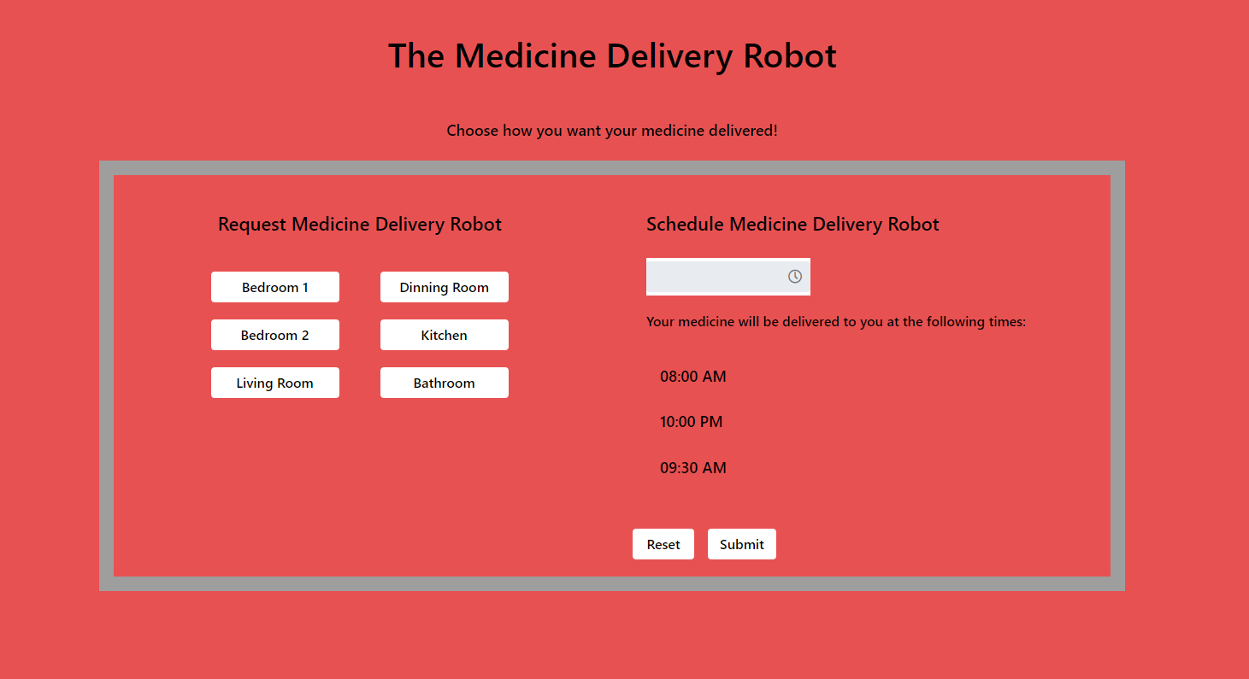

### GitHub Code Repository

<https://github.com/BrockStech/MedicineDeliveryRobot>

# 

# 

# 

# 

# 

# Project Management

### Meeting Log

*\*Logged time is just an estimate. Actual time would be much more than times shown\**

|  |  |  |  |  |  |
| --- | --- | --- | --- | --- | --- |
| Date | Description | Kevin | Anthony | Brock | All |
| 1/16/2020 | Reduce Robot Size | 6 | 6 | 0 | 12 |
| 1/20/0202 | Meet with 3D Print Specialist to determine cost for printing/parts | 6 | 6 | 0 | 12 |
| 1/21/2020 | Reduce Robot Size after finding out 3D print cost | 4 | 4 | 0 | 8 |
| 1/22/2020 | Create Test Plan Document | 0 | 0 | 3 | 3 |
| 1/22/2020 | Presentation Preparation / Raspberry Pi Setup | 3 | 3 | 3 | 9 |
| 1/24/2020 | Meeting with Janet Dong | 2 | 2 | 0 | 4 |
| 1/28/2020 | Call and email part specialist & work on test robot | 2 | 2 | 2 | 6 |
| 1/29/2020 | Presentation Preparation | 3 | 3 | 0 | 6 |
| 1/29/2020 | Automate Delivery Times | 0 | 3 | 3 | 6 |
| 1/30/2020 | Project Design Presentation | 3 | 1 | 0 | 4 |
| 1/30/2020 | Create Getting Started User Guide | 0 | 0 | 2 | 2 |
| 1/31/2020 | Raspberry Pi setup and ordered Motors + Sensors | 1 | 1 | 1 | 3 |
| 2/4/2020 | Robot Motor Design | 3 | 3 | 1 | 7 |
| 2/5/2020 | Robot Motor Design | 2 | 2 | 0 | 4 |
| 2/11/2020 | Implement index motor function | 0 | 0 | 5 | 5 |
| 2/11/2020 | Gear selection | 3 | 3 | 0 | 6 |
| 2/12/2020 | Implement index motor function | 0 | 0 | 1 | 1 |
| 2/18/2020 | Medicine Indexing Assembly. Code testing. Part ordering | 8 | 8 | 8 | 24 |
| 2/20/2020 | Tomcat Setup on Raspberry Pi + Auto Start web app on boot | 0 | 0 | 6 | 6 |
| 2/25/2020 | Add room buttons to UI | 0 | 0 | 2 | 2 |
| 2/25/2020 | Meeting/Tour 1819 Lab | 3 | 3 | 0 | 6 |
| 3/1/2020 | Create Expo Poster | 0 | 0 | 2 | 2 |
| 3/2/2020 | Implement Ultrasonic Sensors | 0 | 0 | 3 | 3 |
| 3/3/2020 | Build, Wire, and program Ultrasonic Sensors and Index Motor | 6 | 7 | 7 | 20 |
| 3/4/2020 | Clean up code & add alarm functionality | 0 | 0 | 2 | 2 |
| 3/5/2020 | 3D printing at 1819 | 2 | 2 | 0 | 4 |
| 3/6/2020 | Add functionality for multiple sensors & create unit tests | 0 | 0 | 4 | 4 |
| 3/9/2020 | Aquire 3D printed parts from labs | 2 | 0 | 0 | 2 |
| 3/9/2020 | Begin development for robot movement | 0 | 0 | 4 | 4 |
| 3/10/2020 | Test/Fix Alarm, Multi Senors & Index Motor. Assemble base | 5 | 5 | 7 | 17 |
| 3/21/0202 | Discuss work arounds that were caused by corona virus | 2 | 2 | 2 | 6 |
| 3/23/2020 | Discuss work arounds that were caused by corona virus | 1 | 1 | 1 | 3 |
| 3/25/2020 | Team 'Microsoft Teams' Meeting to discuss gear box | 1 | 1 | 1 | 3 |
| 3/29/2020 | Attempt to order final parts for project | 1 | 0 | 0 | 1 |
| 3/29/2020 | Team 'Microsoft Teams' Meeting to discuss parts we won't have | 2 | 2 | 2 | 6 |
| 4/3/2020 | Begin project presentation and final report | 3 | 2 | 1 | 6 |
| 4/7/2020 | Webex Meeting with Janet Dong | 1 | 1 | 1 | 3 |
| 4/12/2020 | Team 'Teams' Meeting to discuss project presentation/report | 1 | 1 | 1 | 3 |
| 4/14/2020 | Team 'Teams' Meeting to work on project presentation/report | 2 | 2 | 0 | 4 |
| 4/15/2020 | Tidy up GitHub page & work on final report | 2 | 2 | 3 | 7 |
| 4/16/2020 | Document working sensors, motor and gear box | 4 | 4 | 4 | 12 |
| 4/17/2020 | Finalize presentation and report | 5 | 5 | 5 | 15 |
| TOTAL |  | 89 | 87 | 87 | 263 |

### 

# References:

1. **Samadi, David D.** History and the future of Robotic Surgery. *Robotic Oncology.* [Online] [Cited: Sep 05, 2019.] https://www.roboticoncology.com/history-of-robotic-surgery/.

2. **Tug, the Busy Little Robot Nurse, Will See You Now.** *Wired.* [Online] May 25, 2018. [Cited: Sep 05, 2019.] https://www.wired.com/story/tug-the-busy-little-robot-nurse-will-see-you-now/.

3. **The TUG Autonomous Robot.** *Aethon.* [Online] [Cited: Sep 05, 2019.] https://aethon.com/mobile-robots-for-healthcare/.

4. **Panasonic Autonomous Delivery Robots - HOSPI - Aid hospital Operations at Changi General Hospital.** *Panasonic Newsroom.* [Online] Panasonic Corporation, Jul 23, 2015. [Cited: Sep 05, 2019.] https://news.panasonic.com/global/topics/2015/44009.html.

5. **Hospi. *Wikipedia.*** [Online] Aug 16, 2019. [Cited: Sep 05, 2019.] https://en.wikipedia.org/wiki/Hospi.

6. **Savioke.** Savioke. *Savioke.com.* [Online] Savioke , april 9, 2014. [Cited: September 19, 2019.] https://www.savioke.com/.

7. **Sollitto, Marlo.** Top 6 Problems with Medication Adherence in Seniors. *Agingcare.com.* [Online] April 25, 2019. [Cited: September 19, 2019.] https://www.agingcare.com/articles/medication-problems-elderly-people-have-146111.htm.

8. **iRobot.** Roomba. *iRobot.* [Online] iRobot, 2019. [Cited: September 19, 2019.] https://www.irobot.com/roomba.

9. **Barhum, Lana.** What is the average height for women? *MedicalNewsToday.* [Online] March 6, 2018. [Cited: December 1, 2019.] https://www.medicalnewstoday.com/articles/321132.php.

10. **RobotShop.** Parallax PING ULtrasonic Sensor. *RobotShop.* [Online] RobotShop Inc., December 3, 2019. [Cited: December 3, 2019.] https://www.robotshop.com/en/parallax-ping-ultrasonic-sensor.html.